Rangefinder - a Lab Report

Abstract
In this laboratory,we investigated a laser-based rangefinder system using different measurement methods based on time delay and phase shift of modulated light. We verified the operation of key components, including the mixer and low-pass filter, through DC and AC measurements. We performed distance measurements with direct time-of-flight, phase-shift, and time-zooming. The results showed that direct time-of-flight measurement has limited precision at short distances, while phase-based methods give more reliable results. Using offset compensation, the refractive index of a glass piece was estimated as n ≈ 1.33. The overall achievable measurement precision of the system was found to be on the order of centimeters.

Multiplication and Squaring

The objective of this measurement was to verify the DC multiplication behavior of the mixer circuit. It was performed using different input voltage combinations X1 and Y1​. The measured output voltage Uref∗ is summarized below.

X1​ [V] | Y1​ [V] | Expected X1⋅Y1​ [V] | Measured Uref∗ [V]
1 | 1 | 1.00 | 0.948 ± 0.002
0.3 | 0.5 | 0.15 | 0.173 ± 0.002
0.3 | 0.25 | 0.075 | 0.104 ± 0.002
0.15 | 0.25 | 0.0375 | 0.070 ± 0.002
-0.3 | 0.5 | -0.15 | -0.101 ± 0.002
-0.3 | -0.5 | 0.15 | 0.181 ± 0.002
The measured output voltage follows the expected multiplication behavior: Correct sign (negative inputs → negative output, double negative → positive), output increases with increasing input magnitude.

However, there is a systematic deviation between expected and measured values: For larger inputs (1 V · 1 V), the result is slightly lower than expected (~5% error), for smaller inputs, the measured values are higher than expected; the effective scaling is not perfectly linear across the full range.

Voltage Divider
The applied generator voltages were scaled down by the input voltage dividers. This confirms that: The division ratios are approximately correct however not perfectly consistent across the full range, leading to increasing deviation at smaller signal levels.

AC multiplication and squaring
Results at 20 kHz:

X1​[Vamp] | Y1​[Vamp] | Expected amplitude behavior | Measured Uref∗​amplitude [V] | Measured frequency [kHz] | Measured DC offset [V]
0.3 | 0.5 | positive | 0.13 ± 0.01 | 40 ± 1 | 0.105 ± 0.001
0.3 | 0.25 | smaller positive | 0.075 ± 0.01 | 40 ± 0.01 | 0.071 ± 0.001
0.15 | 0.25 | even smaller positive | 0.038 ± 0.01 | 40 ± 0.02 | 0.053 ± 0.001
-0.3 | 0.5 | negative product | 0.139 ± 0.04 | 40 ± 0.1 | -0.035 ± 0.001
-0.3 | -0.5 | positive product | 0.140 ± 0.05 | 40 ± 0.1 | 0.106 ± 0.001

Results at 20 MHz:

X1​[Vamp] | Y1​[Vamp] | Expected amplitude behavior | Measured Uref∗​amplitude [V] | Measured frequency [kHz] | Measured DC offset [V]
0.3 | 0.5 | positive | 0.051 ± 0.002 | 40.26 ± 0.05 | 0.087 ± 0.001
0.3 | 0.25 | smaller positive | 0.027 ± 0.002 | 39.62 ± 0.05 | 0.060 ± 0.001
0.15 | 0.25 | even smaller positive | 0.0134 ± 0.005 | 39.50 ± 0.05 | 0.048 ± 0.001
-0.3 | 0.5 | negative product | 0.048 ± 0.0002 | 40.1 ± 0.1 | -0.014 ± 0.001
-0.3 | -0.5 | positive product | 0.050 ± 0.004 | 40.32 ± 0.05 | 0.086 ± 0.001

When two sinusoidal signals of the same frequency are multiplied, cos⁡(ωt)cos⁡(ωt) = 1/2[1 + cos⁡(2ωt)] so the output contains a DC component and a double-frequency component. This agrees with the measurements: for 20 kHz input the output was about 40 kHz, and for 20 MHz input it was about 40 MHz.

The sign of the DC offset followed the sign of the product, so one negative input gave a negative offset, while two negative inputs gave a positive one. Negative amplitudes were therefore realized by phase inversion of one input.

Variable-gain amplifier / damper
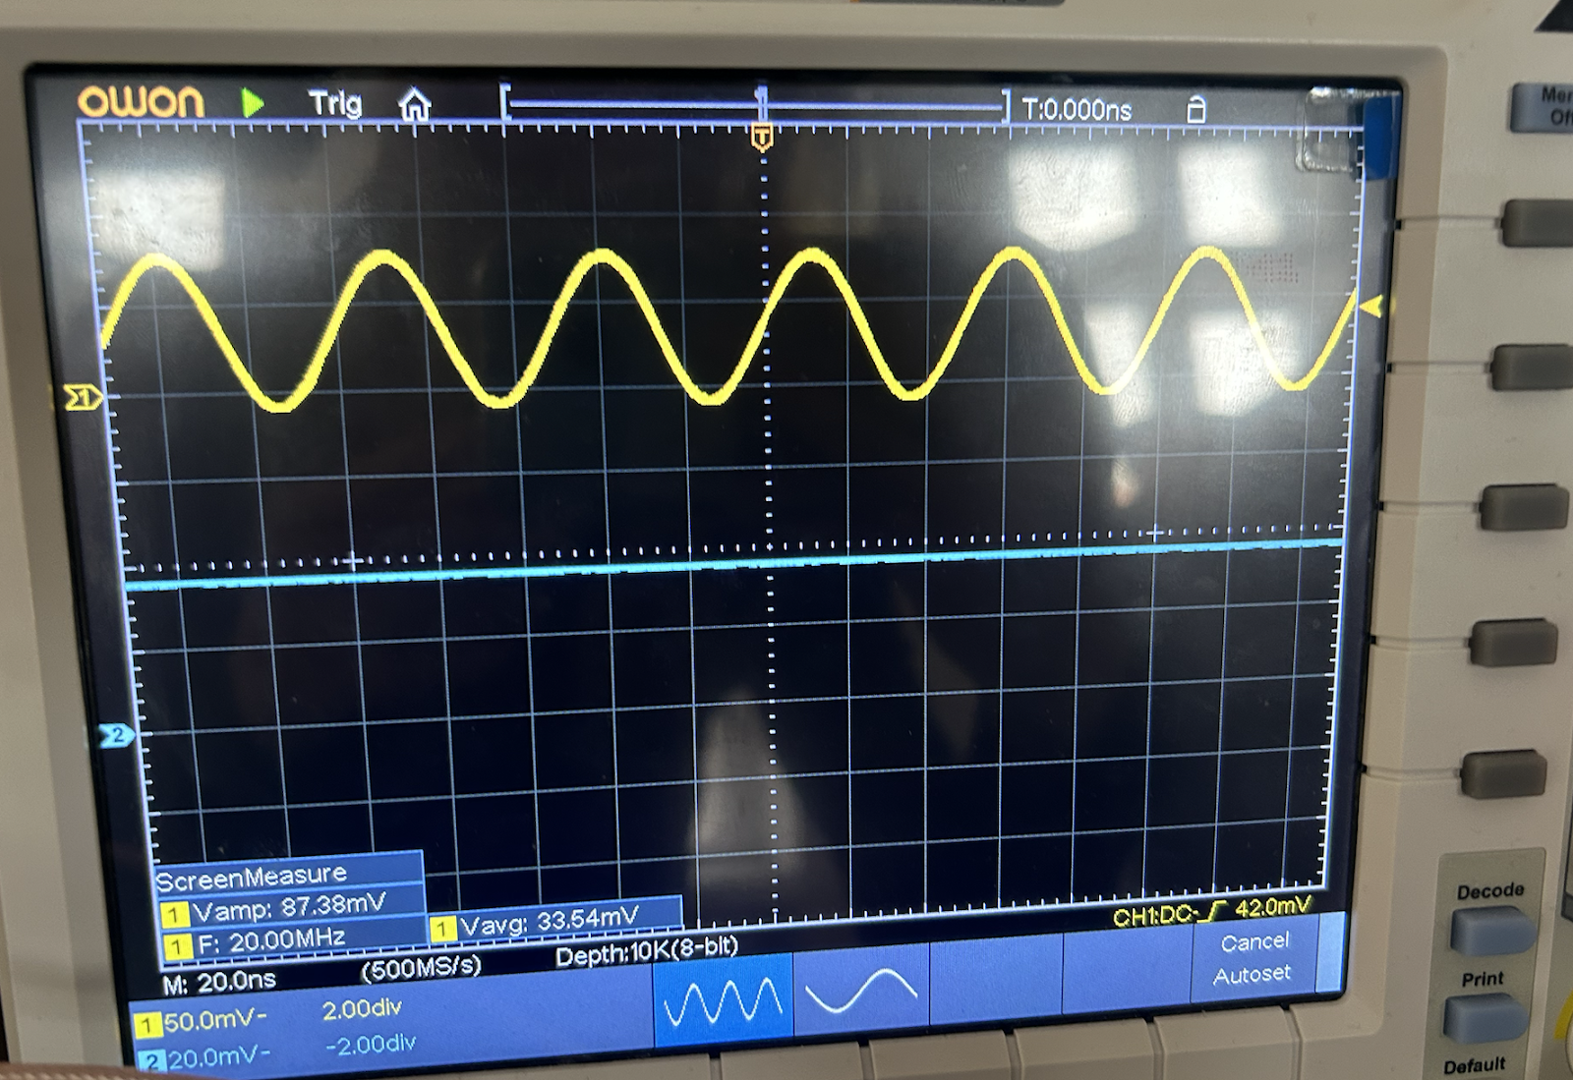

Results at 20 kHz:

Y1​ [V] | Measured Uref∗​ amplitude [V] | Measured frequency [kHz]
0.5 | 0.136 ± 0.005 | 20 ± 0.03
0.25 | 0.070 ± 0.005 | 20 ± 0.005
0 | 0 | 0
-0.25 | 0.078 ± 0.005 | 20 ± 0.005
-0.5 | 0.128 ± 0.005 | 20 ± 0.03

Results at 20 MHz:

Y1​ [V] | Measured Uref∗​ amplitude [V] | Measured frequency [kHz]
0.5 | 0.087 ± 0.005 | 20 ± 0.005
0.25 | 0.042 ± 0.004 | 20 ± 0.005
0 | 0 | 0
-0.25 | 0.045 ± 0.005 | 20 ± 0.005
-0.5 | 0.088 ± 0.004 | 20 ± 0.005

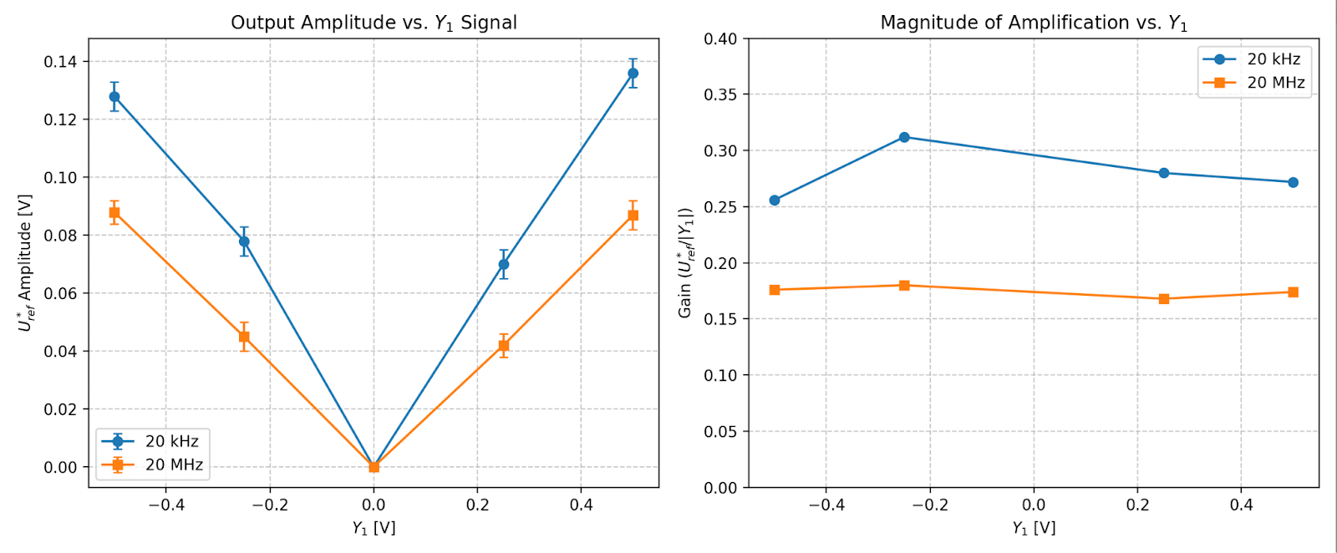Figure 1: The magnitude of the output amplitude as a function of Y1
As seen in Figure 1, the mixer operated as a variable-gain amplifier, where the output amplitude increased approximately proportionally with ∣Y1∣. At Y1 = 0, the output is zero, confirming full suppression of the AC signal. For example, increasing ∣Y1∣ from 0.25 to 0.5 raised the output from about 0.070 V to 0.136 V at 20 kHz, and from 0.042 V to 0.087 V at 20 MHz. The relationship is kind of linear, though small deviations were observed, likely due to non-ideal circuit behavior and measurement uncertainty.
Applying negative Y1​ inverted the signal polarity without affecting its frequency. Since amplitude is measured as a positive quantity, this appeared as a phase reversal rather than a negative amplitude. The output magnitude remained nearly the same for positive and negative Y1​ (e.g., ~0.136 V vs. ~0.128 V at 20 kHz).

Characteristics of the LP filter
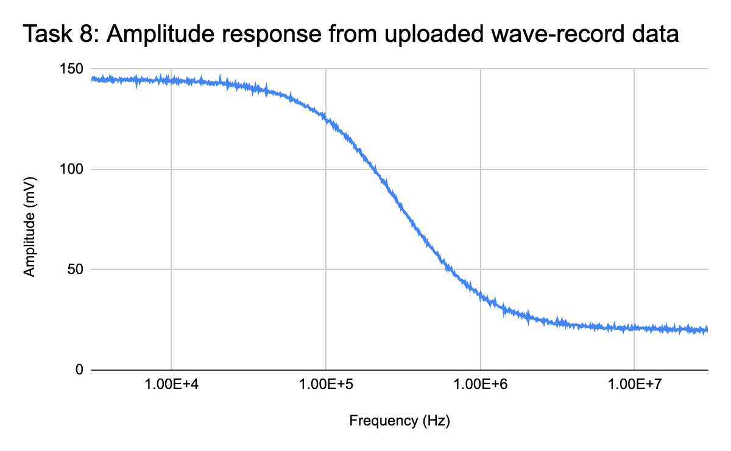
Figure 2a: Amplitude response from frequency sweep: amplitude voltage vs frequency

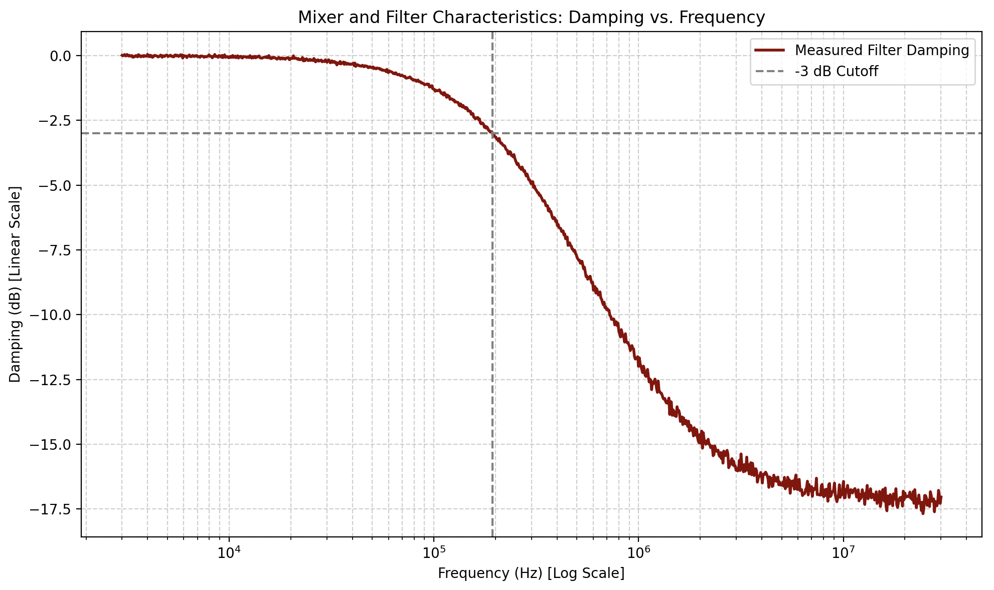
Figure 2b: mixer and filter characteristics (damping vs. frequency) on a lin-log scale

For this task, a 1V DC signal was applied to the mixer’s Y1 input alongside a 2 Vpp sine wave at X1, and a logarithmic frequency sweep was performed from 3 kHz to 30 MHz. During this sweep, both the unfiltered mixer output (Uref) and the low-pass filtered output (UrefLP) were observed.
The measured sweep showed that the unfiltered mixer output amplitude remained relatively constant over the investigated frequency range. In contrast, the filtered output decreased with increasing frequency following a distinct low-pass roll-off curve. This confirms that the low-pass filter successfully attenuates the higher-frequency components of the mixer output, matching the expected behavior for this stage of the circuit.
At lower frequencies (the passband), the filtered output followed the mixer output with minimal attenuation, maintaining a maximum amplitude of approximately 145 mV. As the frequency increased beyond the calculated -3 dB cutoff frequency of approximately 193.6 kHz, the filtered signal became increasingly damped, ultimately dropping to around 20 mV (roughly -17 dB of damping) at 30 MHz. Meanwhile, the raw, unfiltered mixer output remained much less affected. This clearly demonstrates the isolating role of the LP filter: the low-frequency component is preserved, whereas the higher-frequency part is heavily suppressed.
Overall, the sweep measurement confirmed the expected behavior of the transmitter output stage: the mixer output was broadly observable over the full sweep range, while the LP-filtered output showed increasing attenuation as frequency increased. Therefore, the filter functions effectively to suppress the unwanted higher-frequency part of the mixed signal.

Characteristics of the laser diode
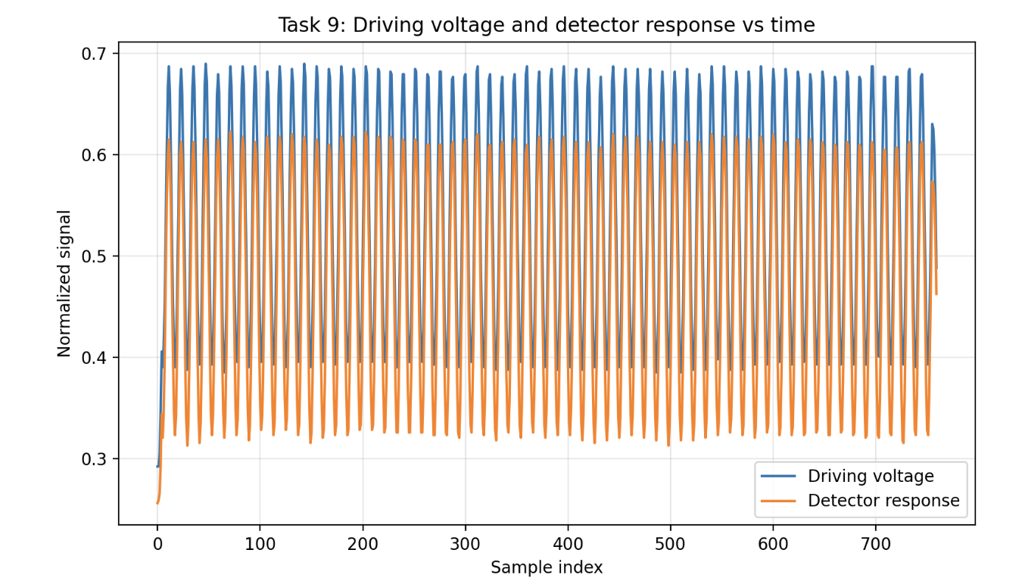
Figure 3: driving voltage and detector response vs time

Measurements of the laser driving voltage and detector response over time (Figure 3) revealed a strongly nonlinear relationship. While the driving signal is sinusoidal, the detector response is non-sinusoidal, appearing only during the peak of each cycle. This indicates that the laser only emits significant light once the driving voltage reaches a specific level, resulting in narrow output peaks rather than a full sine wave.
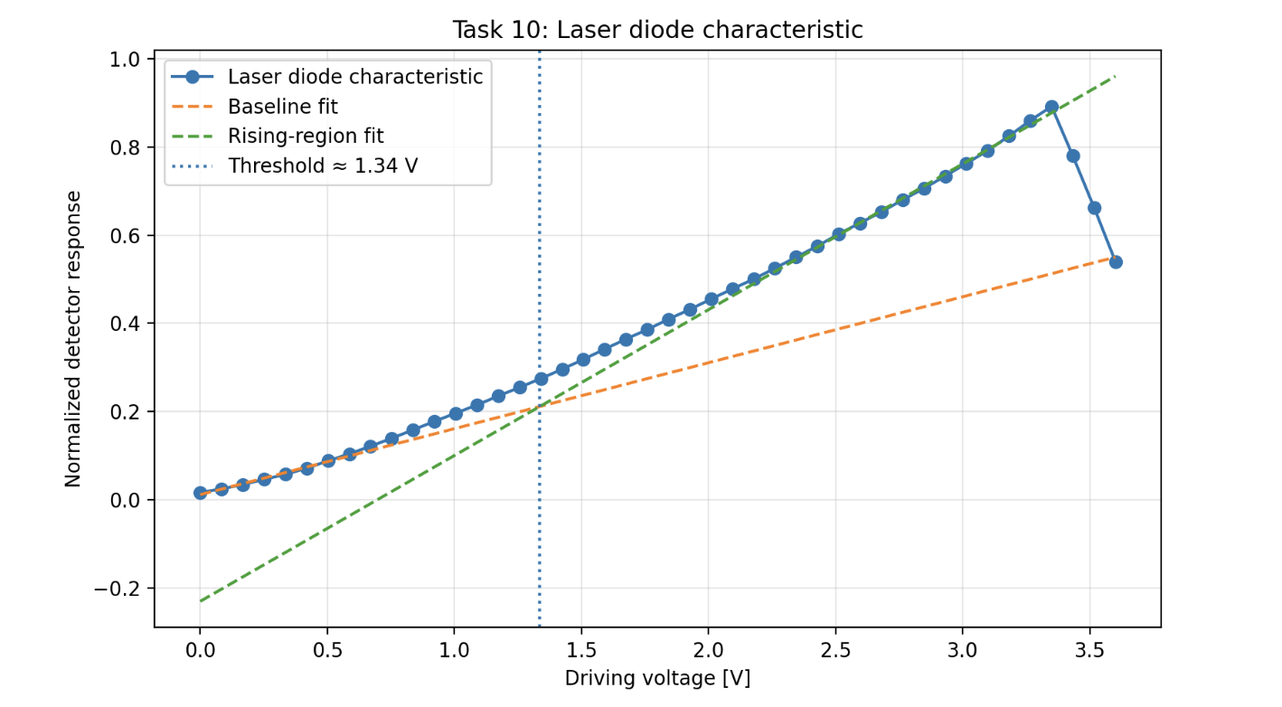
Figure 4: laser diode characteristics

Threshold Voltage: Based on the intersection of the baseline and rising-region fits in Figure 4, the threshold voltage Uth was determined to be 1.34 V.

The curve in Figure 4 shows two distinct regions: Below Threshold: A baseline region where the detector output is nearly negligible, and above Threshold: A steep, linear increase in detector response as the laser begins to lase.

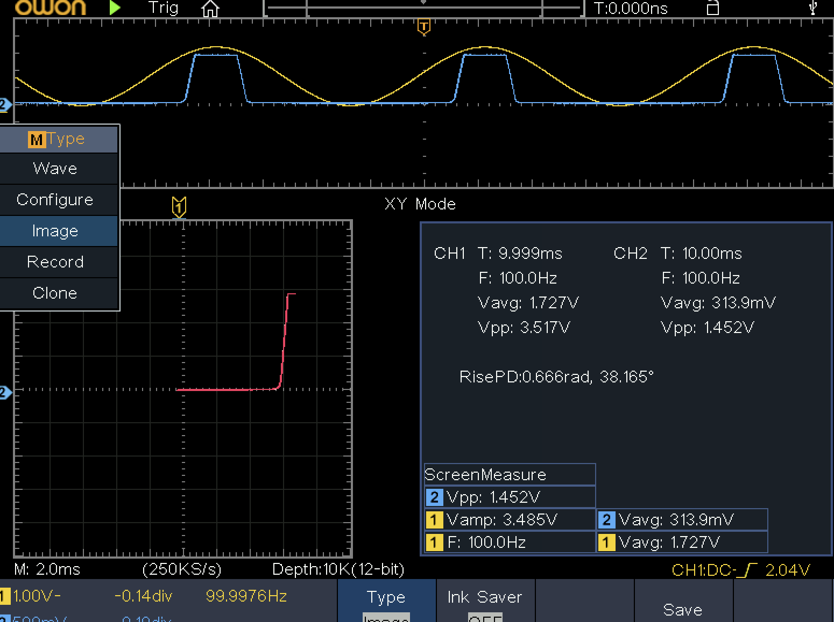

Time-of-flight measurement

From the lab notes, the measured temporal offset at the minimum distance was
toffs = 25 ns

d [cm] | t [ns] | Δt=t−26.9 [ns] | Δdtape​ [cm] | Δdcalc​ [cm] | Error [cm]
3.0 | 26.9 | 0.0 | 0.0 | 0.0 | 0.0
6.5 | 27.8 | 0.9 | 3.5 | 27.0 | +23.5
44.5 | 30.0 | 3.1 | 41.5 | 92.9 | +51.4
53.0 | 30.4 | 3.5 | 50.0 | 104.9 | +54.9
89.0 | 31.4 | 4.5 | 86.0 | 134.9 | +48.9
Error: distance reading: ±0.5 cm; time reading: ±0.3 ns

The measured delay increased with increasing transmitter–receiver distance, so the setup clearly detected the propagation-time change: at 3 cm, the measured time was 26.9 ns, at 89 cm, it increased to 31.4 ns. Thus, the total delay change over this distance interval was
Δt = 31.4 − 26.9 = 4.5 ns for a tape-measured distance change of
Δd = 89 − 3 = 86 cm This gives an experimental slope of ΔtΔd​ ≈ 4.586​ ≈ 19.1 cm/ns

Comparison with tape measurement: the calculated distance increments listed in the notes are much larger than the tape-measured increments: for a tape increment of 3.5 cm, the calculated value was 27.0 cm, for a tape increment of 86.0 cm, the calculated value was 134.9 cm.
So the agreement is poor, and the error becomes very large: +23.5 cm, +51.4 cm, +54.9 cm, +48.9 cm. The measured temporal changes were too small to give accurate short-range distance values
Estimated precision: ±0.3 ns.±0.3 ns.
Factors limiting the measurement range and precision: Resolution, signal quality, human error
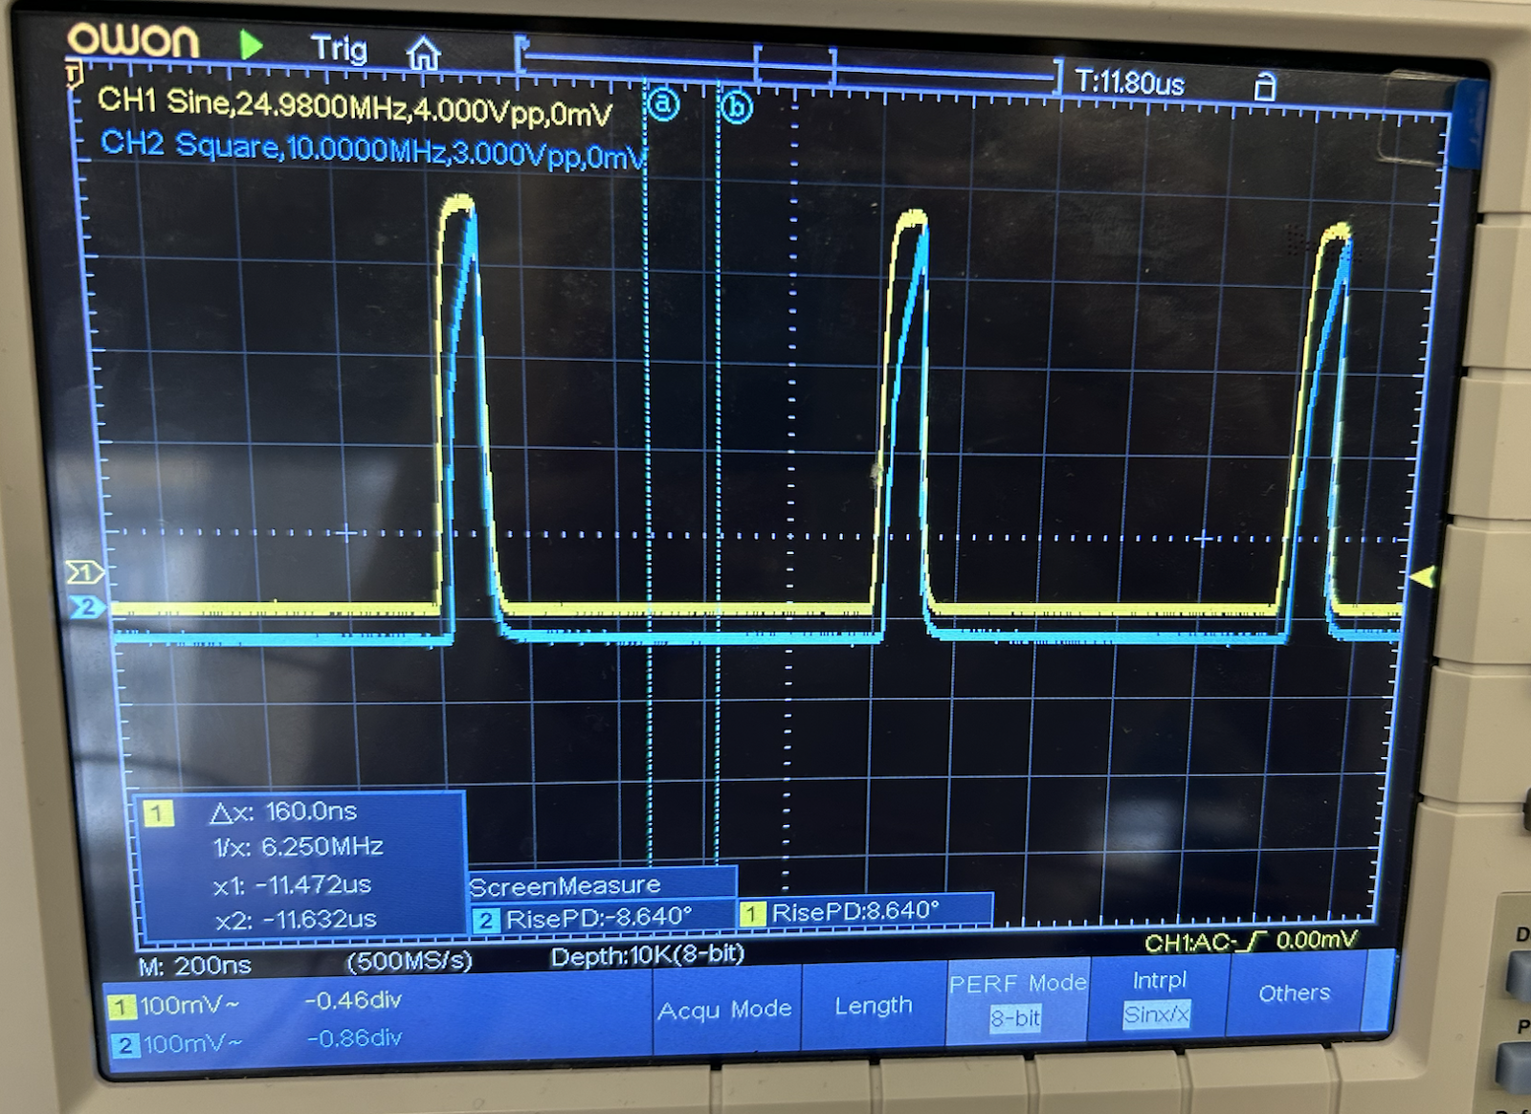

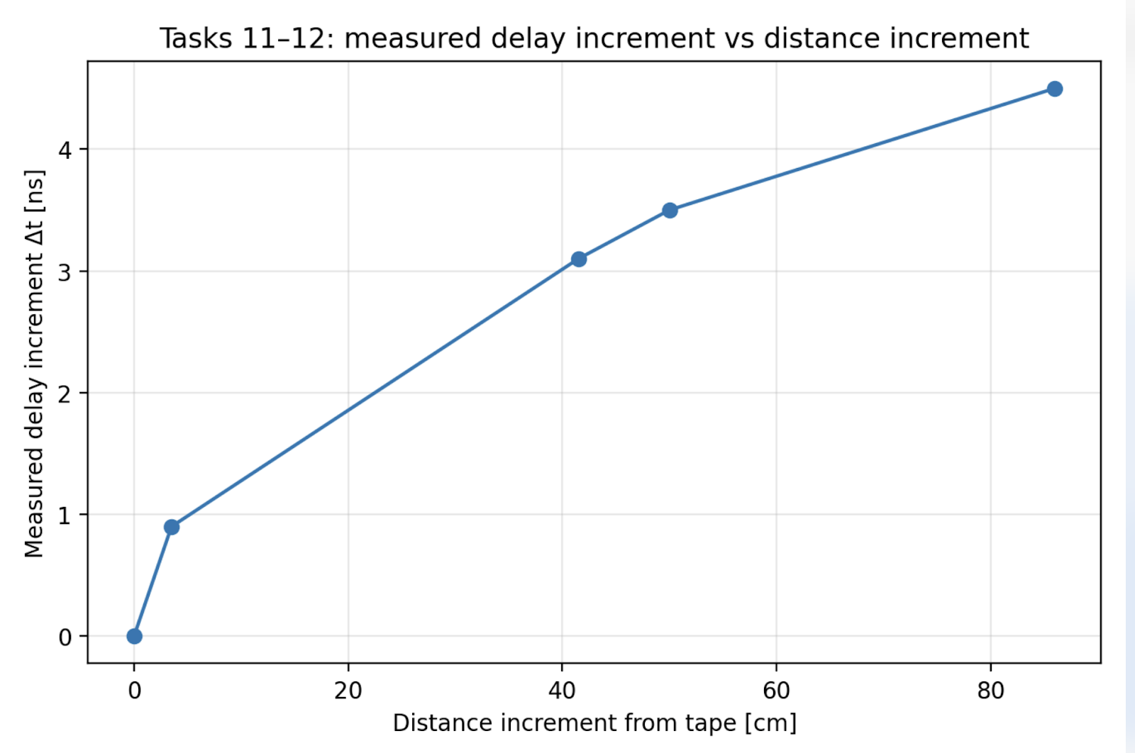
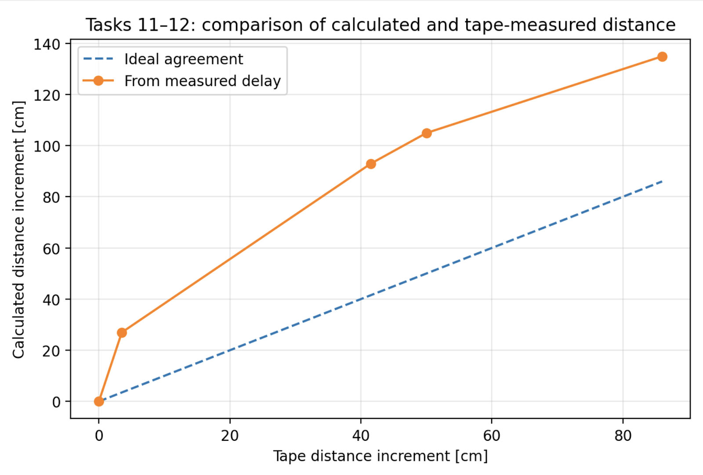
Figure 5: the measured delay increment increases with distance increment

Figure 6: comparison of calculated and tape-measured distance increments and clearly shows the large deviation.

Phase shift of the high-frequency signal
Measurement precision: distance: ±0.5 cm; phase:±2∘

d [cm] | ΔPhase [°]
3.0 | 16
27.5 | 23
58.5 | 48
89.0 | 59

Key Findings & Precision: Total Measured Shift: A change of 43° over 86 cm, resulting in a slope of approximately 0.50°/cm.
Precision: This method is more stable than direct time-of-flight readings. However, with a reading uncertainty of ±2°, small distance changes (like the 7° shift between 3 cm and 27.5 cm) carry a high relative error

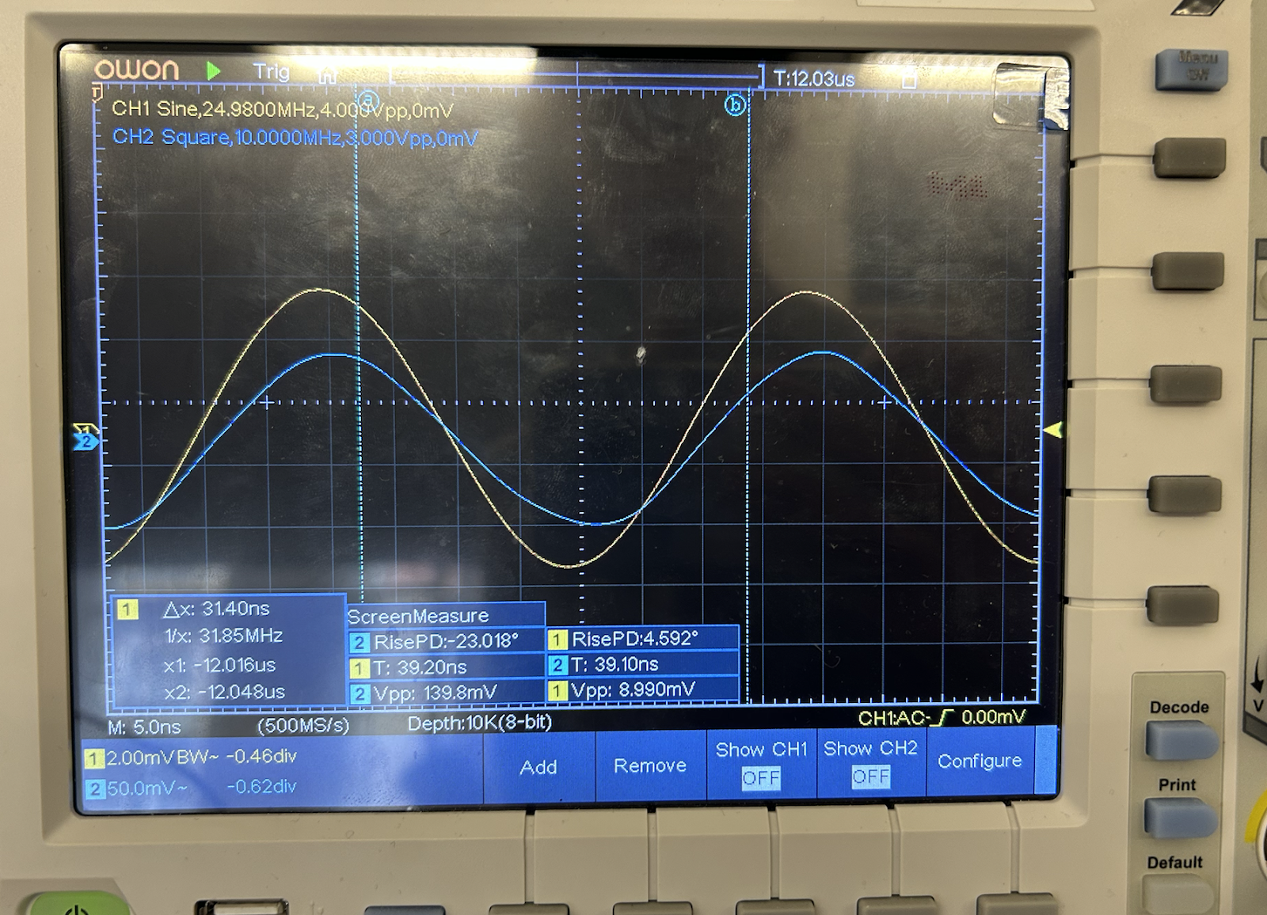
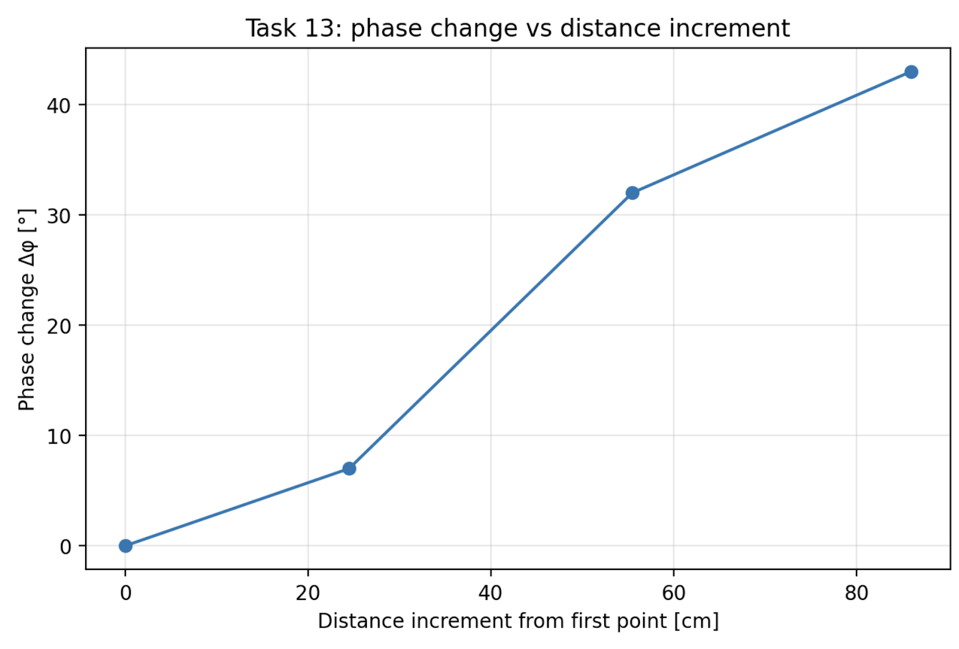
Figure 6: The plot illustrates a linear trend. While there is slight variance between points, the clear upward slope validates that the propagation path change produces a measurable and predictable phase shift in the high-frequency signal.

Maximum Unambiguous Distance: To avoid phase ambiguity, the maximum distance must stay within one modulation period 360°. Given a modulation frequency of 25 MHz:
- T = 1/f = 40 ns
- dmax = c * T = 12m
The maximum measurable distance within one modulation period is approximately 12 meters. Beyond this, the phase wraps around, making the measurement ambiguous.

Time zooming

d [cm] | Phase [°] | ΔPhase [°]
3.0 | 54.72 | 0.00
22.5 | 59.0 | 4.28
48.5 | 61.3 | 6.58
90.0 | 80.6 | 25.28

Δtapp = 8.8 ± 0.2 ns
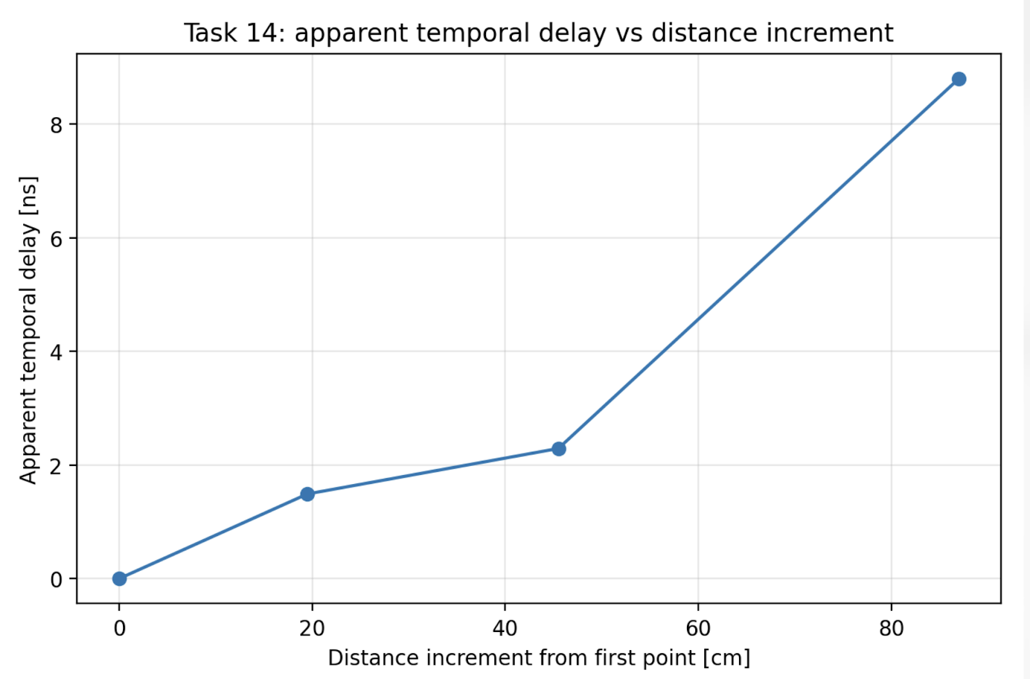
Figure 6: temporal delay vs time increment, the apparent temporal delay increases linearly and monotonically with distance.

A distance increment of 87 cm produced a phase shift of 25.28°, resulting in a slope of 0.29°/cm.
Readability: Unlike Task 13, the phase information is transformed into an apparent delay of 8.8 ± 0.2 ns, which is far easier to evaluate on an oscilloscope than nanosecond-scale pulse shifts.
Temporal Magnification: The system achieves magnification by mixing the modulation frequency fM =25 MHz with a slightly offset frequency Δf = 20 kHz, creating a difference frequency M = fM/Δf = 1250

Precision: Enhanced Readability:Reduced reading error, a shift that would be nearly invisible on a 25 MHz carrier becomes a clear, measurable interval on the 20 kHz signal.

Offset compensation
Refractive index of the glass
Offset compensation was used to zero the initial phase difference, making the delay introduced by the glass easier to isolate. While this technique significantly improves the accuracy of the measurement by eliminating systematic phase offset errors, it does not fundamentally improve the precision of the system. The overall precision (statistical repeatability) remains constrained by the inherent ±0.5 to 1 cm reading uncertainty of the detection and phase measurement chain.
- Measured Phase Shift: Increased from 210° to 212°
- Calculated Delay : 0.222 ns
- Optical Path Increase: 6.67 cm
- Refractive Index: Calculated using the glass length L = 20.5 cm: n = 1 + ΔL/L ≈ 1.33 ± 0.3
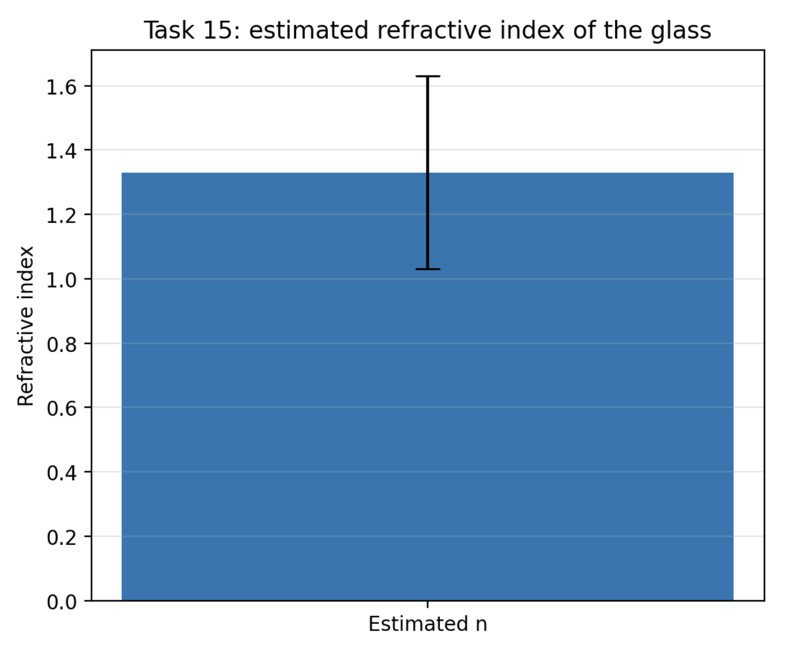
Figure 8: illustration of the final estimate, the large error bar ±0.3 reflects the high relative uncertainty when measuring a very small
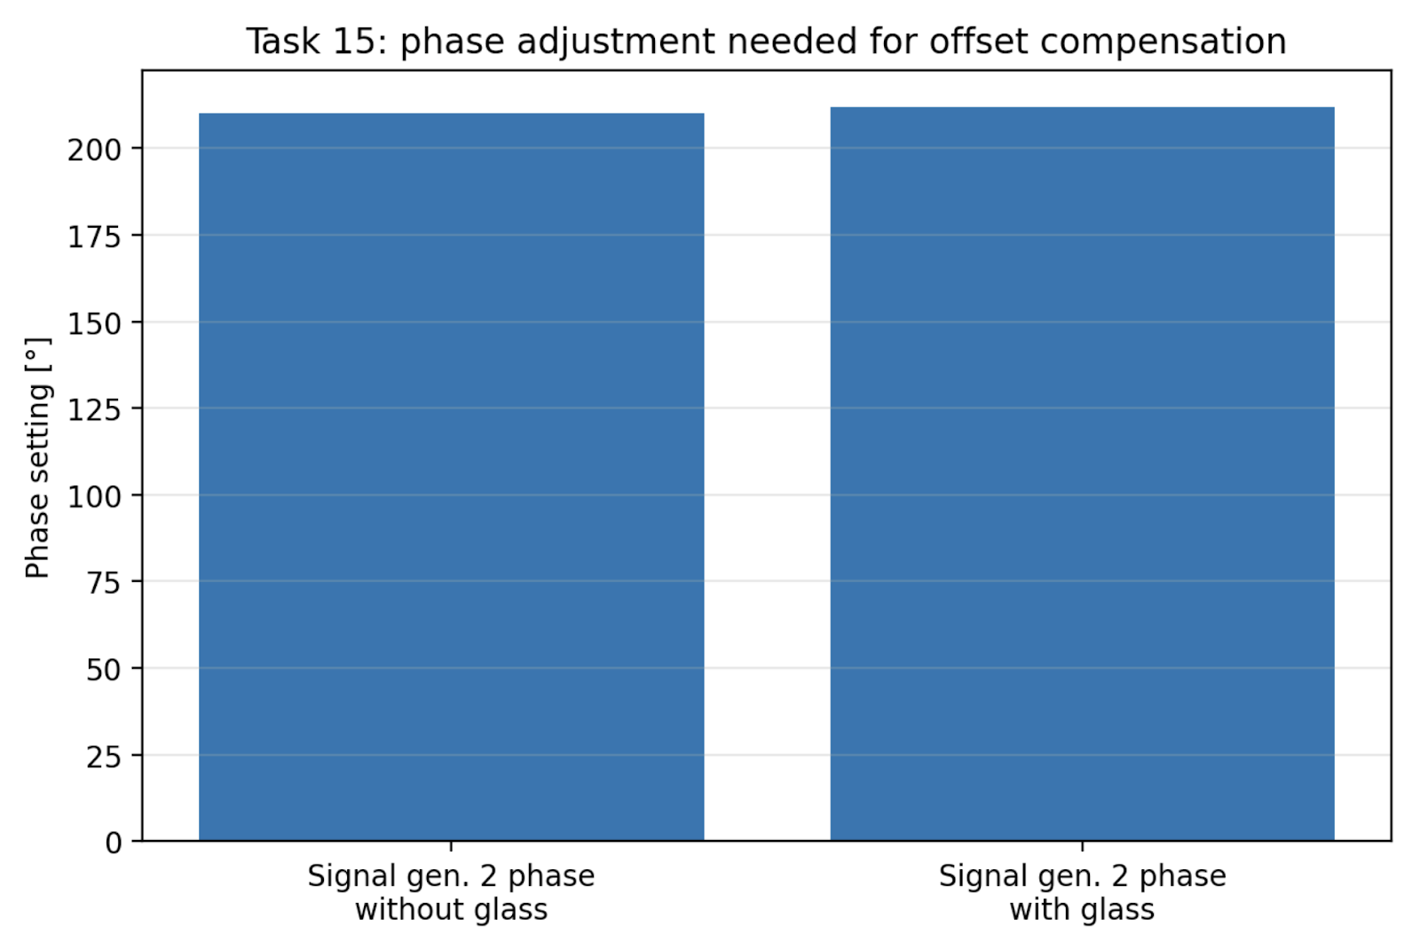
Figure 9 shows the phase adjustment required for compensation.

Square-Wave Modulation:
Switching from a sine wave to a square wave significantly shifted the measured phase offset to -66.2° ± 1°

Although a square wave contains infinite higher harmonics, the detected signal appeared smoothed and dominated by the fundamental frequency, as well as the measurement chain (optical detector, mixer, and low-pass filters) acts as a filter that attenuates high-frequency components, preventing the higher harmonics of the square wave from being clearly visible in the output.

Double-path setup

​​In this configuration, the receiver is placed adjacent to the transmitter, and the beam is reflected from a mirror. This creates a round-trip optical path that requires a specific geometric interpretation.

Measurement Results: d1= 96 cm, d2 = 95 cm
The results indicate that the system remains stable and repeatable even when using a folded optical path (mirror reflection).
Precision and Uncertainty: the observed precision is ± 0.5 – 1 cm.
This matches the performance seen in the previous task, confirming that the practical precision of the rangefinder remains on the order of centimeters.

Triangular Correction: Because the transmitter and receiver are physically separated, the light travels along two sides of a narrow triangle rather than a perfectly overlapped straight line.
- The actual optical path length is slightly longer than 2d.
- In this specific lab setup, the measured values were already very close to the tape-measured distances. Because the separation is small relative to the total distance, the correction is negligible, it does not significantly shift the result beyond the existing 1 cm measurement uncertainty.

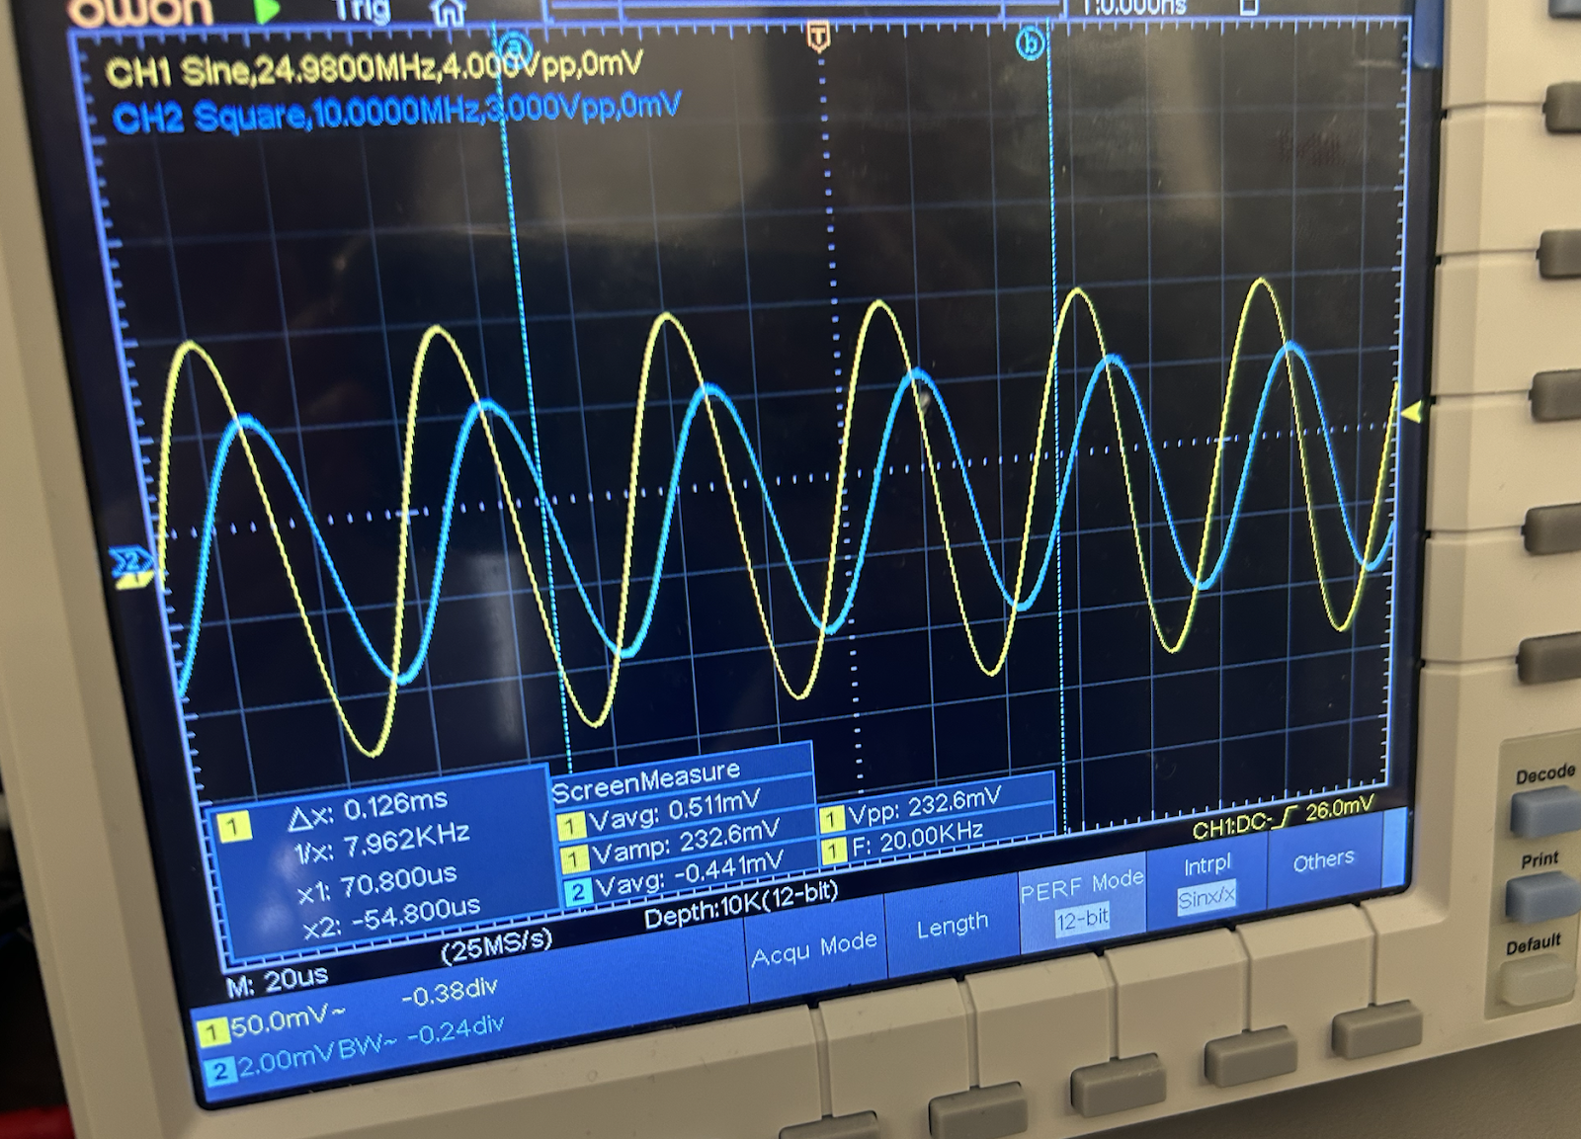

Conclusion
The measurements confirmed that the mixer circuit operates correctly in multiplication and variable-gain modes, and that the low-pass filter effectively suppresses high-frequency components. Among the investigated methods, direct time-of-flight measurement proved to be inaccurate for short distances due to very small delay changes relative to the measurement uncertainty. In contrast, phase-based techniques, especially with time zooming, provided clearer and more easily measurable results. Offset compensation simplified the evaluation and enabled the estimation of the refractive index of a glass sample. The final measurements in the double-path setup showed good repeatability, with an overall precision of approximately ±1 cm. Overall, phase-based distance measurement with time zooming is the most effective method in this setup.

